Java Steps
New --> Java project
Toggle down java project --> Right click on src.
Create a package --> Right click on package name you created.
Create a java class.
You have to create a new java class in every problem.

Don't forget to click on public static void main.
Don't give spaces while writing your java class.

Shortcut for public static void main(String[] args)
{} is main() ctrl + space + enter

Sout + space +enter is command for system.out.println()

Variables
Variables are considered as Containers for value storage.(x=9,name,9.5);
Data types (int, char, float) should be defined before using them in order to avoid error.
Declaration of variable is done only once.

Flow of code
main is the backbone of code.
1. Start --> main
2. Read(a,b)
3. Print
4. End

Operators
1. Arithmetic operators: ( +, -, *, /, %, ++ , --)

2. Assignment operators: (=, !=, +=, -=, *=, /=, %= )

3. Comparing operators: (==, !=, >, >=, <, <=)

4. Logical operators: (&&, ||, !)

5. Bitwise operators. [Bitmasking]

1. Arithmetic operators:
Addition, Subtraction, Multiplication, Division, modulus, increment, decrement.

2. Comparing operators:
equal to, not equal to, greater than, greater than equal to, less than, less than equal to.

3. Logical operators: Logical (AND, OR, NOT).
AND: both conditions should be true in order to get output true.
OR: if any one condition or both condition is true, the output will be true.
NOT: it reverses the input true to false and vice versa.
If – else condition:
If( ){ else{
}
}
If condition always gives output for true values.
Else condition counters the false condition of if and provides output.
LOOPS
Loops are used to do tasks repeatedly with some given conditions.
There are three types of loops:

1. While : 2. For :
3. Do while : (Runs at least once ever after the conditions are matched.)

1. While Loop:
It is used when number of iterations are unknown.
We should have starting ending points and iterations(increment, decrements) as well.
If there are no iterations, it will run infinitely.
It should have a counter variable to keep track of iterations or number in particular we say Counter variable.
Syntax:
while (condition) {
// code block to be executed
}
Working / Format of loop:
Start --> Read (a) --> condition check --> print --> increment --> end
Steps:
The condition is evaluated before each iteration.
If the condition is true, the code block is executed.
The loop continues as long as the condition remains true.
If the condition is false at the start, the loop body will not execute at all.

2. For loop:
It is useful when the number of iterations is known beforehand.
We should have starting ending points and iterations(increment, decrements) as well.
If there are no iterations, it will run infinitely.
It should have a counter variable to keep track of iterations or number in particular we say Counter variable.
Syntax:
for (initialization; condition; increment) {
// code block to be executed
}
Working / Format of loop:
Start --> Read (a) --> condition check --> print --> increment --> end

Steps:
The initialization step is executed once at the beginning.
The condition is evaluated before each iteration.
If the condition is true, the code block is executed.
After the code block is executed, the increment step is executed.

3. For Each Loop
The "for-each" loop (also known as the enhanced for loop) is a control structure used to iterate over elements in a collection or array.
Unlike a traditional `for` loop, which requires an explicit counter or index, the `for-each` loop is designed to simplify iteration by abstracting away these details.
Syntax:
for (Type element : collection) {
// Code to execute for each element
}
Type: The type of elements in the collection.
element: The variable that represents each element in the collection.
collection: The array or collection (like a list, set, etc.) to iterate over.

Working
The `for-each` loop works by iterating over each element in a collection, executing a block of code for each element without the need to manage an index or counter.
Here's how it works internally:
1. Initialization: The loop starts by getting the first element in the collection.
2. Iteration: The loop iterates over the collection, processing each element one by one.
3. Termination: The loop terminates automatically when there are no more elements left in the collection.

Steps to Implement For-Each Loop from Scratch
To implement a `for-each` loop from scratch, you'll typically need to define a custom iterator for your collection.
The steps are as follows:
1. Define a Collection:
This could be an array, list, or any other data structure that holds multiple elements.
2. Create an Iterator:
An iterator is an object that enables traversal of a collection.
It provides methods to check if more elements are available (`hasNext`) and to get the next element (`next`).
3. Implement Iterable Interface (in languages like Java):
This interface requires you to define a method that returns an iterator.
4. Use the Iterator in a Loop:
The loop uses the iterator to traverse the collection and process each element.

Summary
Syntax: The `for-each` loop syntax simplifies iteration over collections.
Working: It iterates through each element in a collection without needing an index or counter.
Steps: To implement it from scratch, create a collection, define an iterator, and use that iterator in a loop.
OOPS
1. Classes and Objects
Class : A blueprint for creating objects (a particular data structure).
Object: An instance of a class.

2. Attributes and Methods
Attributes: Variables that belong to a class (also known as properties or fields).
Methods: Functions that belong to a class.

3. Encapsulation
The concept of bundling data and methods that work on that data within one unit, e.g., a class.
Restricts direct access to some of the object's components.

4. Inheritance
Mechanism for a new class to inherit the attributes and methods of an existing class.

5. Polymorphism
The ability to present the same interface for different data types.
Allows methods to do different things based on the object it is acting upon.

6. Abstraction
The concept of hiding the complex implementation details and showing only the essential features of the object.
Achieved through abstract classes and interfaces (in languages like Java, C#).
Benefits of OOP
Modularity: The source code for a class can be written and maintained independently of the source code for other classes.
Reusability: Classes can be reused across multiple programs.
Pluggability and Debugging Ease: If a particular object turns out to be problematic, it can be removed and replaced without affecting the rest of the system.
Principles of OOP
1. Encapsulation: Binding the data and methods that manipulate the data together and keeping both safe from outside interference and misuse.
2. Abstraction: Hiding the complex reality while exposing only the necessary parts.
3. Inheritance: A mechanism where a new class is derived from an existing class.
4. Polymorphism: Allowing entities to be represented in multiple forms.

Multiple Inheritance and Operator Overloading
Operator Overloading
It allows developers to redefine the way operators work for user-defined types (such as classes).
You can specify what an operator (like +, -, *, ==) should do when applied to objects of your class.
It provides a way to make your class behave more like built-in types.
Example: Overloading the `+` Operator
#include <iostream>
using namespace std;
class Complex {
private:
double real;
double imag;
public:
Complex(double r = 0, double i = 0) : real(r), imag(i) {}
// Overload the + operator
Complex operator+(const Complex& other) const {
return Complex(real + other.real, imag + other.imag);
}
// Function to display the complex number
void display() const {
cout << real << " + " << imag << "i" << endl;
}
};
int main() {
Complex c1(3.0, 4.0);
Complex c2(1.0, 2.0);
Complex c3 = c1 + c2; // Using the overloaded + operator
c3.display(); // Output: 4 + 6i
return 0;
}
Multiple Inheritance
MI is a feature in C++ where a class can inherit from more than one base class.
This allows a derived class to inherit attributes and methods from multiple base classes.
Example:
Consider the following example where class `D` inherits from both classes `B1` and `B2`:
#include <iostream>
using namespace std;
class B1 {
public:
void displayB1() {
cout << "Base class B1" << endl;
}
};
class B2 {
public:
void displayB2() {
cout << "Base class B2" << endl;
}
};
class D : public B1, public B2 {
public:
void displayD() {
cout << "Derived class D" << endl;
}
};
int main() {
D obj;
obj.displayB1(); // Calling method from B1
obj.displayB2(); // Calling method from B2
obj.displayD(); // Calling method from D
return 0;
}
In this example, class `D` inherits from both `B1` and `B2`, and thus it can access methods from both base classes.
Diamond Problem
One of the issues with multiple inheritance is the "diamond problem," which occurs when two classes `B1` and `B2` inherit from a common base class `A`, and class `D` inherits from both `B1` and `B2`.
This can lead to ambiguity about which copy of the base class `A` should be used.
#include <iostream>
using namespace std;
class A {
public:
void display() {
cout << "Base class A" << endl;
}
};
class B1 : public A {};
class B2 : public A {};
class D : public B1, public B2 {};
int main() {
D obj;
// obj.display(); // This will cause a compilation error due to ambiguity
obj.B1::display(); // Resolving ambiguity by specifying the path
obj.B2::display(); // Resolving ambiguity by specifying the path
return 0;
}
To avoid the diamond problem, C++ introduces virtual inheritance:
#include <iostream>
using namespace std;
class A {
public:
void display() {
cout << "Base class A" << endl;
}
};
class B1 : virtual public A {};
class B2 : virtual public A {};
class D : public B1, public B2 {};
int main() {
D obj;
obj.display(); // No ambiguity due to virtual inheritance
return 0;
}
In this example, `B1` and `B2` virtually inherit from `A`, ensuring that there is only one copy of `A` in the derived class `D`.

Difference between JAVA and C++
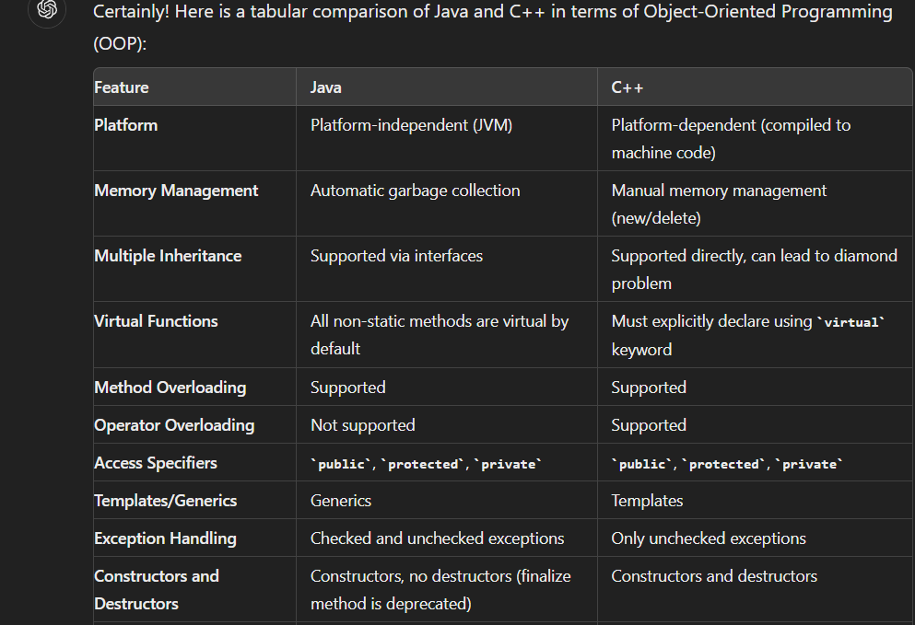
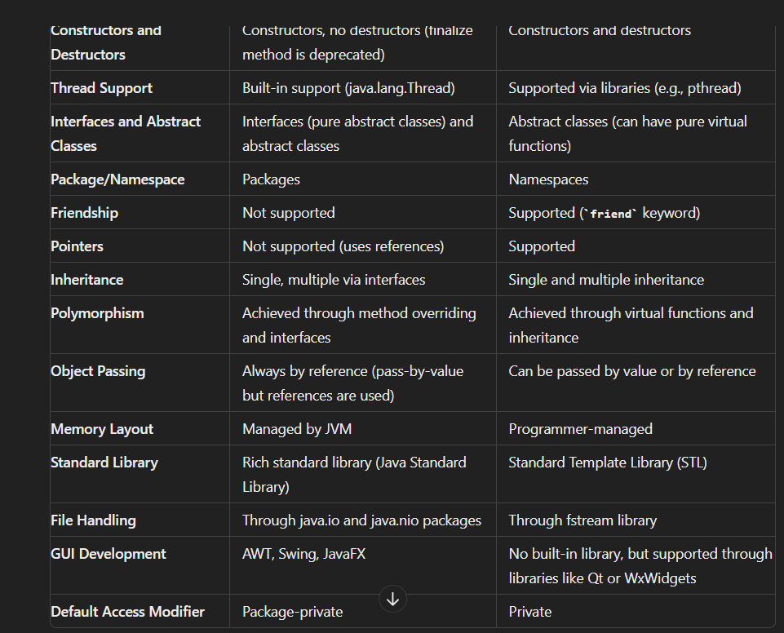
METHOD OVERLOADING
If a class has multiple methods having same name but parameters of the method should be different is known as Method Overloading.
If we have to perform only one operation, having same name of the methods increases the readability of the program.
Different ways of Method Overloading in Java
1. Type of parameter should be different:
Eg: void add (int, int); void add (double,double);

2. Number of parameter should be different:
Eg: void add(int a, int b) void add(int a, int b,int c)

3. By changing the Order of the parameters
public void order(String name, int id) public void order(int id, String name)

Access Specifiers/Modifiers
Access modifiers help to restrict the scope of a class, constructor, variable, method, or data member.
It provides security, accessibility, etc to the user depending upon the access modifier used with the element.

Types:
Default – No keyword required Private Protected Public

Default:
When no access modifier is specified for a class, method, or data member – It is said to be having the default access modifier by default.
The data members, classes, or methods that are not declared using any access modifiers i.e. having default access modifiers are accessible only within the same package.
Private
The private access modifier is specified using the keyword private.
The methods or data members declared as private are accessible only within the class in which they are declared.
- Any other class of the same package will not be able to access these members.
- Top-level classes or interfaces can not be declared as private because
- private means “only visible within the enclosing class”.
- protected means “only visible within the enclosing class and any subclasses”

Protected
The protected access modifier is specified using the keyword protected.
The methods or data members declared as protected are accessible within the same package or subclasses in different packages.

Public
The public access modifier is specified using the keyword public.
- The public access modifier has the widest scope among all other access modifiers.
- Classes, methods, or data members that are declared as public are accessible from everywhere in the program. There is no restriction on the scope of public data members.
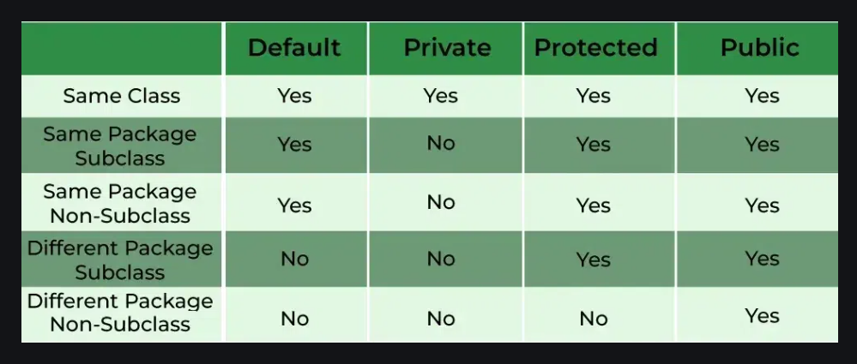
Getters and Setters
They are methods used to protect your data and make your code more secure.
They make the programmer convenient in setting and getting the value for a particular data type.
Getter in Java:
Getter returns the value (accessors), it returns the value of data type int, String, double, float, etc.
For the program’s convenience, the getter starts with the word “get” followed by the variable name.

Setter in Java:
While Setter sets or updates the value (mutators).
It sets the value for any variable used in a class’s programs. and starts with the word “set” followed by the variable name.
Note: In both getter and setter, the first letter of the variable should be capital.
Syntax
class ABC{
private variable;
public void setVariable(int x){
this.variable=x;
}
public int getVariable{
return variable;
}
}
CONSTRUCTOR & DESTRUCTOR
Constructors and destructors are special member functions in OOP languages that handle object initialization and cleanup, respectively.

Constructors
It is a special member function that initializes objects of a class.
It is called automatically when an object is created.
Constructors have the same name as the class and do not have a return type.
Types
1. Default Constructor:
A constructor that takes no parameters.
If no constructors are defined, the compiler provides a default constructor.
Non primitive: Null Primitive : depends on data type (bool false, int 0)
2. Parameterized Constructor:
A constructor that takes parameters to initialize the object with specific values.
3. Copy Constructor:
A constructor that creates a new object as a copy of an existing object.
4. Move Constructor:
A constructor that transfers resources from a temporary object to a new object (C++11 and later).
Characteristics of Constructors
Implicit Call: Constructors are called implicitly when an object is created.
Overloading: Multiple constructors can be defined in a class (constructor overloading).
Initialization List: Constructors can use an initialization list to initialize data members.
Syntax
class CN {
public:
CN(); // Default Constructor
CN(int a, double b); // Parameterized Constructor
CN(const ClassName &obj); // Copy Constructor
CN(ClassName &&obj); // Move Constructor
~ CN(); // Destructor
};
Destructors
A destructor is a special member function that cleans up when an object is destroyed.
It is called automatically when the object goes out of scope or is explicitly deleted.
Destructors have the same name as the class, preceded by a tilde (~), and do not take parameters or return a value.
Characteristics of Destructors:
Implicit Call: Destructors are called implicitly when an object goes out of scope or is explicitly deleted.
No Overloading: Only one destructor can be defined in a class.
Resource Cleanup: Destructors are commonly used to release resources such as memory, file handles, or network connections.
Syntax
class CN {
public:
~ CN(); // Destructor
};
Example
~MyClass() {
cout << "Destructor called" << endl;
}
Advantages of Cons and Des
Automatic Initialization and Cleanup:
They ensure that resources are properly initialized and cleaned up without requiring explicit function calls by the programmer.
Encapsulation:
They help encapsulate the initialization and cleanup logic within the class, leading to more maintainable and modular code.
Consistency:
They provide a consistent way to initialize and destroy objects, reducing the risk of errors such as memory leaks and resource mismanagement.
Flexibility:
Constructor overloading allows for flexible initialization options.
RAII:
Promotes Resource Acquisition Is Initialization (RAII) principles, which help in resource management and exception safety.
Disadvantages of Cons and Des
Complexity:
Overloading and proper use of constructors and destructors can add complexity to the class design.
Overhead:
Implicit calls to constructors and destructors add overhead, especially in performance-critical applications.
Rule of Three/Five:
Implementing the Rule of Three/Five can be error-prone and cumbersome.
Order of Construction and Destruction:
The order in which constructors and destructors are called (especially in inheritance hierarchies) can lead to subtle bugs if not handled correctly.
Applications:
Resource Management:
Managing resources such as dynamic memory, file handles, network connections, and other system resources.
Initialization:
Ensuring that objects are properly initialized before use, such as setting up data structures or configuring settings.
Cleanup:
Ensuring that resources are released and cleaned up when objects are no longer needed, preventing resource leaks.
RAII:
Implementing RAII patterns to manage resources safely and efficiently, especially in the context of exception handling.
Object-Oriented Design:
Facilitating object-oriented design principles by encapsulating initialization and cleanup logic within classes.

Constructors and Destructors in Java
In Java, constructors are special methods used to initialize objects.
Java does not have explicit destructors as in C++, but it has a garbage collector that handles memory cleanup.
We can use `finalize()` method for cleanup tasks, but it's not recommended due to unpredictability.
Constructors
A constructor in Java initializes an object when it is created.
It has the same name as the class and does not have a return type.
Types:
1. Default Constructor:
A constructor that takes no parameters.
If no constructors are defined, the compiler provides a default constructor.
2. Parameterized Constructor:
A constructor that takes parameters to initialize the object with specific values.
3. Copy Constructor:
Java does not provide a built-in copy constructor like C++.
Instead, you can create a copy constructor manually.
Characteristics of Constructors
Implicit Call: Constructors are called implicitly when an object is created.
Overloading: Multiple constructors can be defined in a class (constructor overloading).
Initialization Block: Code that is common to all constructors can be placed in an initialization block.
Syntax
class ClassName {
public ClassName() { // Default Constructor
// Initialization code
}
public ClassName(int a, double b) { // Parameterized Constructor
// Initialization code
}
// Copy Constructor (not built-in, manual implementation)
public ClassName(ClassName obj) {
// Copy initialization code
}
}
Destructors
Java does not support destructors explicitly like C++.
Instead, Java uses a garbage collector to manage memory automatically.
The garbage collector automatically reclaims memory occupied by objects that are no longer reachable in the program.

finalize( ) Method
The `finalize( )` method is called by the garbage collector before an object is destroyed.
However, its usage is generally discouraged due to unpredictability and performance issues.
Detailed Notes on Constructors and Destructors

1. Constructor Overloading:
A class can have multiple constructors with different parameter lists.
The appropriate constructor is chosen based on the arguments provided during object creation.
Example:
public class MyClass {
public MyClass() { }
public MyClass(int x) { }
public MyClass(int x, double y) { }
}

2. Chaining Constructors using this():
A constructor can call another constructor of the same class using the `this()` keyword.
Example:
public class MyClass {
private int a;
private double b;
public MyClass() {
this(0, 0.0); // Calls parameterized constructor
}
public MyClass(int a, double b) {
this.a = a;
this.b = b;
}
}
3. Initialization Blocks:
Initialization blocks are executed before the constructor body.
They can be used for common initialization code.
Example:
public class MyClass {
private int a;
private double b;
// Initialization block
{
a = 10;
b = 20.5;
}
public MyClass() {
Syso("Default Constructor called");
}
public MyClass(int a, double b) {
this.a = a;
this.b = b;
Syso("Parameterized Constructor called");
}
}
Deep Copy and Shallow Copy
Shallow Copy
A shallow copy creates a new object, but instead of creating deep copies of the nested objects, it only copies references to the nested objects.
This means that changes to the nested objects in the original will reflect in the shallow copy, and vice versa.
Deep Copy
A deep copy creates a new object and also recursively copies all objects that are referenced by the original object.
This means changes to the nested objects in the original will not affect the deep copy, and vice versa.
Implicit and Explicit Constructors
Implicit Constructor
It (or default constructor) is a no-argument constructor automatically provided by the compiler if no other constructors are defined in the class.
It initializes the object with default values.
Example:
public class IC {
private int a;
private double b;
// Implicit default constructor is provided by the compiler
public void display() {
Syso("a: " + a + ", b: " + b);
}
public static void main(String[] args) {
IC obj = new IC();
obj.display(); // Outputs: a: 0, b: 0.0
}
}
Explicit Constructor
It is one that is explicitly defined by the programmer.
This includes parameterized constructors or no-argument constructors with specific initialization code.
Example
public class EC {
private int a;
private double b;
// Explicit default constructor
public EC() {
this.a = 1;
this.b = 1.0;
}
// Parameterized constructor
public EC(int a, double b) {
this.a = a;
this.b = b;
}
public void display() {
Syso("a: " + a + ", b: " + b);
}
public static void main(String[] args) {
EC obj1 = new EC();
obj1.display(); // Outputs: a: 1, b: 1.0
EC obj2 = new EC(10, 20.5);
obj2.display(); // Outputs: a: 10, b: 20.5
}
}
Detailed Notes
1. Copy Constructors in Java:
Java does not have a built-in copy constructor like C++, but you can manually create one to perform deep or shallow copies.
2. finalize( ) Method:
The `finalize()` method in Java is called by the garbage collector before the object is destroyed.
However, its usage is discouraged in favour of try-with-resources and other resource management techniques.
3. Garbage Collection:
Java manages memory using a garbage collector, which automatically reclaims memory occupied by objects that are no longer reachable.
4. Constructor Overloading:
Multiple constructors can be defined in a class with different parameter lists.
This is useful for providing different ways to initialize an object.
5. Initialization Blocks:
Common initialization code can be placed in initialization blocks, which are executed before the constructor body.
Advantages
Shallow Copy: Faster to create because it doesn't duplicate nested objects.
Deep Copy:
Ensures full independence of the copied object from the original, avoiding side effects from changes to the original object's nested objects.
Implicit Constructors: Provide a quick way to create objects without explicit initialization.
Explicit Constructors: Allow for precise control over object initialization.
Disadvantages
Shallow Copy:
Changes in the nested objects of the original will affect the copy and vice versa, leading to potential bugs.
Deep Copy:
Slower to create because it duplicates all nested objects, which can be resource-intensive.
Implicit Constructors:
Lack of explicit initialization can lead to uninitialized or default values, which may not be desirable.
Explicit Constructors:
Require more boilerplate code and can make the class definition more complex.
Applications
1. Shallow Copy:
Suitable for situations where object references are sufficient, and deep independence is not required.
2. Deep Copy:
Ideal for scenarios requiring complete independence of copied objects, such as when cloning complex data structures.
3. Implicit Constructors:
Useful for simple classes where default initialization is acceptable.
4. Explicit Constructors:
Essential for classes requiring specific initialization logic or multiple ways of initializing an object.
[ This Static Final ] Keywords
In Java, `static` and `final` are two fundamental keywords that modify the behaviour of classes, methods, and variables.
Static Keyword
It is used to indicate that a member (variable, method, or nested class) belongs to the class itself, rather than to instances of the class.
`static` members can be accessed without creating an instance of the class.

Static Variables (Class Variables)
Shared Among All Instances:
A `static` variable is shared among all instances of a class.
Changes to a `static` variable reflect across all instances.
Memory Efficiency:
Since `static` variables are stored in a fixed location, they reduce memory overhead when used appropriately.
Example:
public class Counter {
static int count = 0; // static variable
Counter() {
count++;
Syso(count);
}
public static void main(String[] args) {
Counter c1 = new Counter(); // Outputs 1
Counter c2 = new Counter(); // Outputs 2
Counter c3 = new Counter(); // Outputs 3
}
}
Static Methods ( SM )
No Access to Instance Variables:
SM can only access `static` variables and other `static` methods.
They cannot access instance variables (`non-static` variables) directly.
Utility Methods:
Commonly used for utility or helper methods that do not require an object’s state.
Example:
public class MathUtil {
static int add(int a, int b) {
return a + b;
}
public static void main(String[] args) {
int result = MathUtil.add(5, 10); // No need to create an instance of MathUtil
Syso(result); // Outputs 15
}
}
Static Blocks
Static Initialization:
`static` blocks are used for static initialization of variables.
They run when the class is first loaded into memory.
One-Time Execution:
A `static` block is executed only once when the class is loaded.
Example:
public class StaticBlockExample {
static int num;
static {
num = 100; // Static block
Syso("Static block executed.");
}
public static void main(String[] args) {
Syso("Value of num: " + num); // Outputs 100
}
}
Static Nested Classes
Associated with Outer Class:
A `static` nested class is associated with its outer class and can be accessed without creating an instance of the outer class.
Cannot Access Non-static Members:
A `static` nested class cannot directly access non-static members of the outer class.
Example:
public class OuterClass {
static class StaticNestedClass {
void display() {
Syso("Inside static nested class.");
}
}
public static void main(String[] args) {
OuterClass.StaticNestedClass nested = new OuterClass.StaticNestedClass();
nested.display(); // Outputs: Inside static nested class.
}
}
`final` Keyword
It is used to restrict the user from changing a variable, method, or class.
Final Variables
Constant Values:
A `final` variable is a constant; once it is initialized, it cannot be modified.
Must Be Initialized:
A `final` variable must be initialized at the time of declaration or in the constructor.
Example:
public class FVE {
final int MAX_VALUE = 100;
void tryChange() {
// MAX_VALUE = 200; // This will cause a compile-time error
}
public static void main(String[] args) {
FVE example = new FVE();
Syso(example.MAX_VALUE); // Outputs 100
}
}
Final Methods
Cannot Be Overridden:
A `final` method cannot be overridden by subclasses.
This is useful when you want to prevent a method from being altered in a subclass.
Example:
class ParentClass {
final void display() {
Syso("Final method in ParentClass.");
}
}
class ChildClass extends ParentClass {
// void display() { // This would cause a compile-time error
// Syso("Overridden method in ChildClass.");
// }
}
public class FME {
public static void main(String[] args) {
ChildClass obj = new ChildClass();
obj.display(); // Outputs: Final method in ParentClass.
}
}
Final Classes
Cannot Be Inherited:
A `final` class cannot be extended.
This is used when you want to prevent a class from being subclassed.
Example:
final class FC {
void display() {
Syso("Final class cannot be extended.");
}
}
// class SubClass extends FC { // This would cause a compile-time error
// }
public class FCE {
public static void main(String[] args) {
FC obj = new FC();
obj.display(); // Outputs: Final class cannot be extended.
}
}
Combining `static` and `final`
The `static` and `final` keywords are often used together for defining constants.
A `static final` variable is a constant that belongs to the class and remains constant across all instances.
Example:
public class Constants {
static final double PI = 3.14159;
static final int MAX_WIDTH = 1024;
public static void main(String[] args) {
Syso("PI: " + PI); // Outputs: PI: 3.14159
Syso("Max Width: " + MAX_WIDTH); // Outputs: Max Width: 1024
}
}
Summary
`static` Keyword:
Static Variables: Shared across all instances, associated with the class.
Static Methods: Can be called without an instance, cannot access instance variables directly.
Static Blocks: Used for static initialization, executed when the class is loaded.
Static Nested Classes: Can be instantiated without an outer class object.

`final` Keyword:
Final Variables: Immutable constants.
Final Methods: Cannot be overridden. Final Classes: Cannot be subclassed.

`static final` Combination:
Used to define constants that are shared across all instances and remain unchanged.
This Keyword
Java provides several keywords, among them, `this`, `static`, and `final` are frequently used to manage references, control access, and enforce immutability.
1. `This` Keyword
It is a reference variable that refers to the current object instance.
It is commonly used in constructors and methods to eliminate ambiguity and access instance variables and methods.
Use Cases of `this`:
Refer to Instance Variables:
When local variables or parameters have the same name as instance variables, `this` helps distinguish between them.
public class Example {
private int value;
public Example(int value) {
this.value = value; // 'this.value' refers to the instance variable
}
}
Invoke Constructor:
`this()` can be used to call another constructor in the same class.
public class Example {
private int value;
private String text;

public Example() {
this(0, "default"); // Calls the second constructor
}
public Example(int value, String text) {
this.value = value;
this.text = text;
}
}
Pass Current Object as an Argument:
You can pass the current object to a method or constructor.
public class Example {
public void print(Example obj) {
Syso("Value: " + obj.value);
}
public void display() {
print(this); // Passes the current object
}
}
2. `static` Keyword
It is used for memory management.
It can be applied to variables, methods, blocks, and nested classes.
The static members belong to the class rather than any instance.
Use Cases of `static`:
Static Variables:
Also known as class variables, they are shared among all instances of the class.
There is only one copy of a static variable per class, regardless of how many instances are created.
public class Example {
static int count = 0; // Static variable
public Example() {
count++; // Increment the count for each object created
}
}
Static Methods:
These methods belong to the class and can be called without creating an instance.
Static methods can only access static variables and other static methods directly.
public class Example {
static int multiply(int a, int b) {
return a * b;
}
}
public class Test {
public static void main(String[] args) {
int result = Example.multiply(2, 3); // Call static method without creating an instance
Syso("Result: " + result);
}
}
Static Block:
A static block is used to initialize static variables.
It is executed only once when the class is loaded into memory.
public class Example {
static int value;

static {
value = 10; // Initialize static variable
Syso("Static block executed");
}
}
Static Nested Class:
A static class defined inside another class.
It can access the static members of the outer class but not the non-static members.
public class OuterClass {
static int value = 10;
static class StaticNestedClass {
void display() {
Syso("Value: " + value); // Access static member of outer class
}
}
}
3. `final` Keyword
It is used to restrict the user from modifying the value of variables, extending classes, or overriding methods.
It ensures that certain aspects of a class remain unchanged once they are defined.
Use Cases of `final`:
Final Variables:
A final variable is a constant and can only be initialized once, either directly or within a constructor.
Once assigned, its value cannot be changed.
public class Example {
final int value = 10; // Final variable, value cannot be changed
}
public class Example {
final int value;
public Example(int value) {
this.value = value; // Final variable initialized in constructor
}
}
Final Methods:
A final method cannot be overridden by subclasses.
This is useful for methods that should remain unchanged in any subclass.
public class Example {
final void display() {
Syso("This method cannot be overridden");
}
}
Final Classes:
A final class cannot be extended.
This is useful when you want to prevent other classes from inheriting and modifying the behaviour of the class.
public final class Example {
// Class implementation
}
Final Parameters:
The value of a final parameter cannot be changed within the method.
public class Example {
void display(final int value) {
// value = 20; // This will cause a compilation error
Syso("Value: " + value);
}
}
Summary
`this` Keyword:
Refers to the current object instance, used to access instance variables, invoke constructors, and pass the current object.
`static` Keyword:
Belongs to the class rather than any instance.
Used for class variables, methods, static blocks, and nested classes.
`final` Keyword:
Prevents modification. Used to create constants (final variables),
prevent method overriding (final methods),
prevent class inheritance (final classes).
Difference between Java and C++
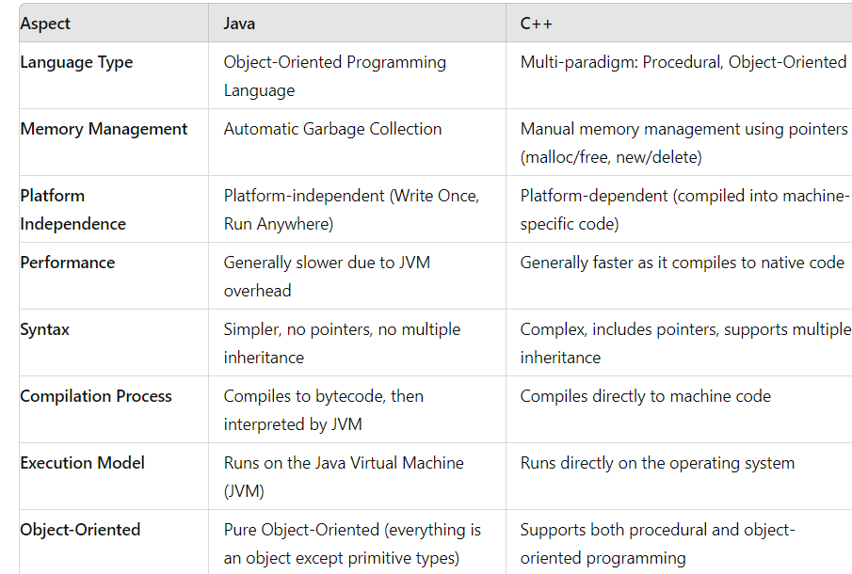
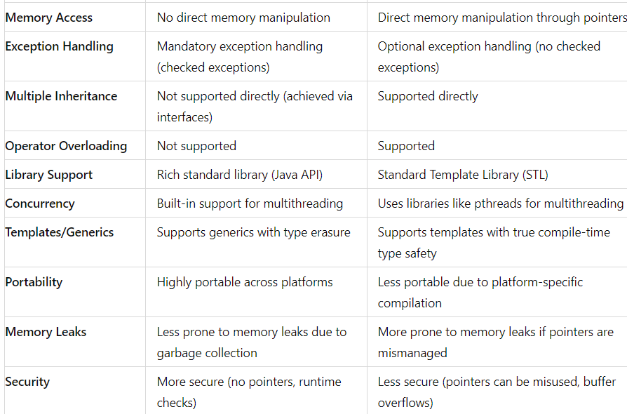
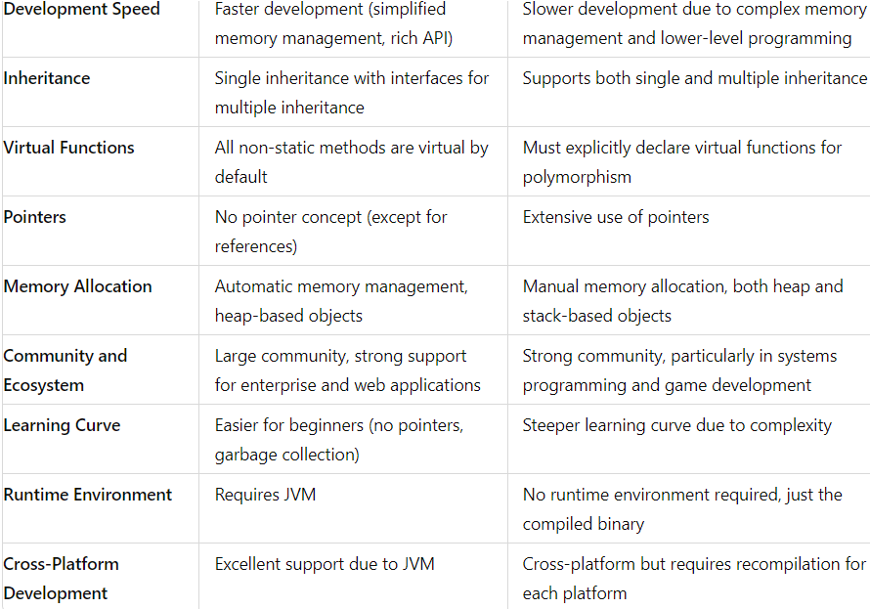
Command Line Arguments ( CLA)
CLA are used to pass information to the `main()` method at runtime.
These arguments are passed as a string array (`String[] args`) to the `main()` method.
Each argument can be accessed using an index, and they are provided when running the program from the command line or terminal.
Working of CLI
When you run a Java program from the command line, you can pass additional arguments after the class name.
The `main()` method in Java is defined as:
public static void main(String[] args) {
// code here
}
The `args` parameter is an array of `String` that contains the command line arguments.
Example:
public class CLE {
public static void main(String[] args) {
Syso("Number of arguments: " + args.length);
for (int i = 0; i < args.length; i++) {
Syso("Argument " + i + ": " + args[i]);
}
}
}
Explanation:
If you run this program with the command `java CLE arg1 arg2 arg3`, output will be:
Number of arguments: 3
Argument 0: arg1
Argument 1: arg2
Argument 2: arg3
Common Operations with CLA
1. Passing Integers:
Since CLA are passed as strings, you need to convert them to the appropriate data type.
Example:
public class SumArguments {
public static void main(String[] args) {
int sum = 0;
for (String arg : args) {
int number = Integer.parseInt(arg); // Convert string to integer
sum += number;
}
System.out.println("Sum: " + sum);
}
}
Command: `java SumArguments 10 20 30` Output: `Sum: 60`

2. Handling No Arguments:
You can check if the `args` array is empty and handle the case where no arguments are provided.
Example:
public class NoArgumentsCheck {
public static void main(String[] args) {
if (args.length == 0) {
Syso("No arguments were provided!");
} else {
for (String arg : args) {
Syso("Argument: " + arg);
}
}
}
}
Command: `java NoArgumentsCheck` Output: `No args were provided!`

3. Passing Multiple Types of Data:
If you want to pass a mix of integers, floats, or other data types, you'll need to convert each argument to its correct type.
Example:
public class MixedArguments {
public static void main(String[] args) {
String name = args[0];
int age = Integer.parseInt(args[1]);
double salary = Double.parseDouble(args[2]);
Syso("Name: " + name);
Syso("Age: " + age);
Syso("Salary: " + salary);
}
}
Command: `java MixedArguments John 30 50000.50`
Output:
Name: John
Age: 30
Salary: 50000.5

Basic Commands for Compilation and Running Java Programs
To compile and run Java programs from the command line, you need to use the Java Development Kit (JDK) tools, specifically
`javac` (for compilation) and `java` (for running the program).

1. Compiling a Java Program
The `javac` command is used to compile Java source files (.java) into bytecode (.class).
Syntax: javac [options] filename.java
Example:
To compile a file named `MyProgram.java`:
javac MyProgram.java
This command generates a `MyProgram.class` file, which contains the bytecode that can be executed by the Java Virtual Machine (JVM).

2. Running a Java Program
The `java` command is used to run the compiled Java program.
Syntax: java [options] classname [args...]
Example:
To run the compiled class `MyProgram.class`: java MyProgram
If `MyProgram` expects CLA, you can pass them after the class name:
java MyProgram arg1 arg2 arg3

3. Compiling and Running Together
You can compile and run the program in one go by chaining the commands:
javac MyProgram.java && java MyProgram

This first compiles the program and then runs it, provided the compilation is successful.
Summary
Command Line Arguments:
Passed to the `main()` method as a `String[]` array, allowing you to input data into a Java program from the command line.
Common Operations:
Converting strings to integers using `Integer.parseInt()`.
Handling cases where no arguments are provided.
Passing and processing different types of data (e.g., integers, strings, floats).

Compilation and Running Commands:
Compiling: Use `javac filename.java` to compile the Java source file into bytecode.
Running: Use `java classname` to run the compiled bytecode.
Combining: Compile and run in one step using `javac filename.java && java classname`.

